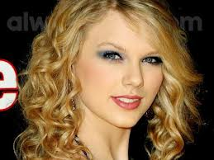
- Swim with a dolphin
- Make the Lake Shore soccer team
- Become a marine biologist
- Go to Paris
- Meet Carrie Underwood
- Meet Blake Shelton
- Have straight A’s for the rest of high school
- Go to England
- Attend Michigan state university
- Go to a Katy Perry concert
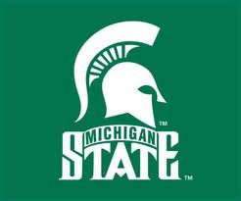
- Meet Taylor Swift

